# Launching a REV UP Campaign

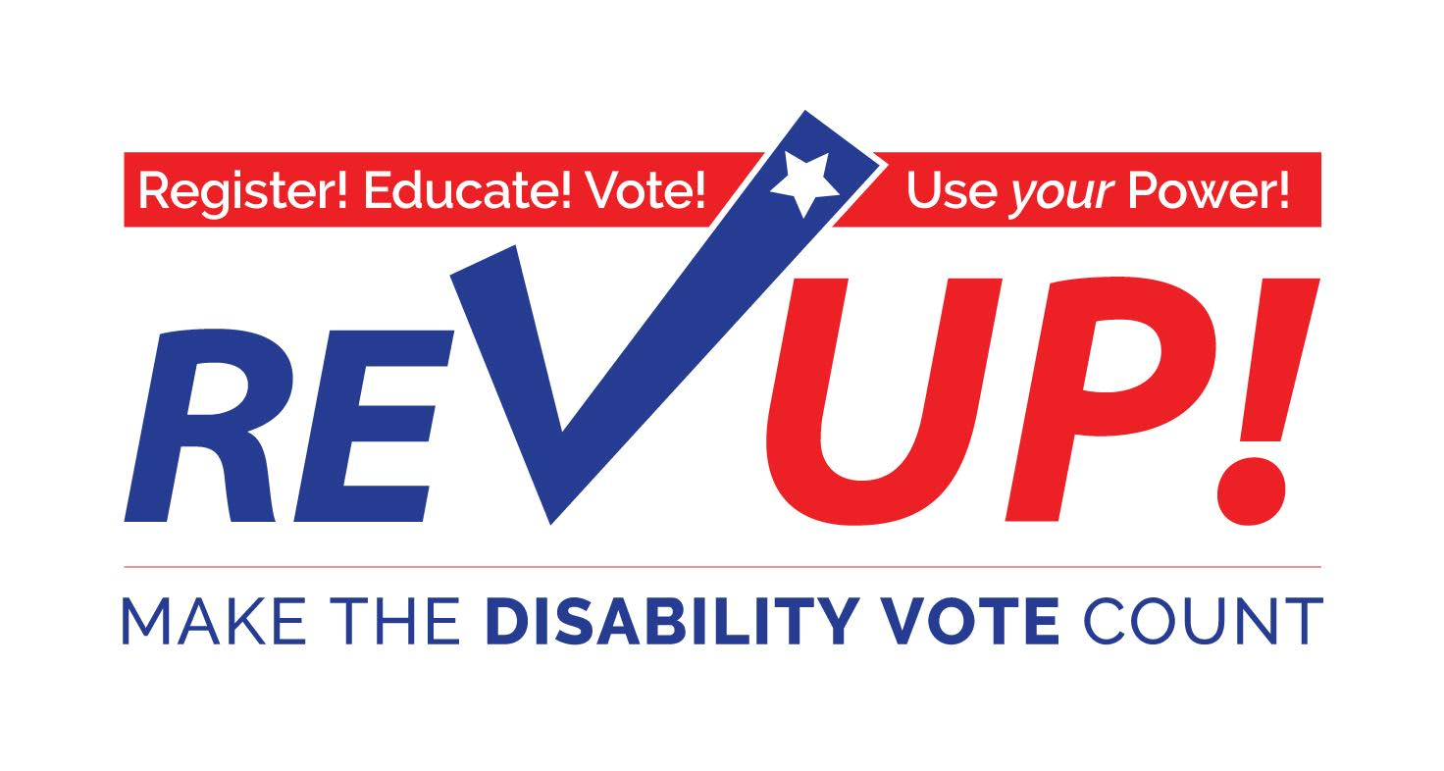

**Register! Educate! Vote! Use your Power!**

The REV UP Campaign is an initiative of the American Association of People with Disabilities (AAPD). AAPD is a convener, connector, and catalyst for change, increasing the political and economic power of people with disabilities.

The REV UP Campaign, which launched in early 2016, engages in nonpartisan activities to increase the political power of the disability community while also engaging candidates and the media on disability issues. REV UP stands for Register! Educate! Vote! Use your Power! REV UP helps organize the disability community at the state and local level to get more people with disabilities registered to vote and involved in the political process. It also raises the national profile of the disability community as an influential voting bloc.

## Statistics

* People with disabilities will account for 35.4 million eligible voters in 2016, approximately one sixth of the total electorate ([*Rutgers University*](http://smlr.rutgers.edu/news/projecting-number-eligible-voters-disabilities-november-2016-elections-research-report)).
* In 2016, there will be 62.7 million eligible voters who either have a disability or have a household member with a disability, more than one-fourth of the total electorate ([*Rutgers University*](http://smlr.rutgers.edu/news/projecting-number-eligible-voters-disabilities-november-2016-elections-research-report)).
* In 2016, the number people with disabilities who are eligible to vote will surpass the number of eligible Black and Latino voters ([*USA Today*](http://www.usatoday.com/story/news/politics/onpolitics/2016/08/12/voters-disabilities-outnumber-black-latino-voters-study/88628272/)).
* In 2012, 56.8% of people with disabilities voted compared to 62.5% of people without disabilities.
* If people with disabilities voted at the same rate as people without disabilities in 2012 there would have been an additional 3 million votes cast.
* In 2012, 30 percent of people with disabilities reported difficulty in voting, compared with 8 percent of people without disabilities ([*Rutgers University*](https://www.supportthevoter.gov/files/2013/08/Disability-and-Voting-White-Paper-for-Presidential-Commission-Schur.docx_.pdf)).

# REV UP 2016 – Accomplishments To Date

## Mobilizing the Grassroots Disability Community

* **Engaging Disability Voting Rights Advocates** – The REV UP Campaign maintains regular direct engagement with over 350 voting rights advocates across 27 states to provide information, resources, and updates. Many of these advocates are representatives from centers for independent living, protection and advocacy agencies, and other state/local disability organizations.
* **Sign-On Letter to Candidates** – The REV UP Campaign partnered with the Interfaith Disability Advocacy Coalition to issue a sign-on letter for the faith community to encourage the presidential candidates to address disability issues.
* **State Resources & Events** – The REV UP Campaign regularly updates a webpage with information about events in states across the country. These events include voter registration and education events, debate watch parties, town halls, candidate forums, and more.
* **REV UP Toolkit & Logos** – The REV UP Campaign offers a customizable toolkit to help advocates at the state and local level collect and organize information and resources that are specific to their state. REV UP also offers a host of logos and graphics that are free for advocates to use and modify.
* **Media Materials** – The REV UP Campaign offers sample social media posts, press release templates, and graphics to aid state and local partners in their communication efforts.

## Voter Engagement

* **National Disability Voter Registration Week** – The week, which occurred on July 11-15, 2016, was organized as a concerted effort to get more people with disabilities registered and educated about this year’s elections as well as to inform the media and candidates for public office about the influence of the disability vote. The REV UP Campaign received 37 official proclamations as well as a joint letter of support from former Senators Bob Dole and Tom Harkin.
* **National Voter Registration Day** – The REV UP Campaign joined the broader national effort on September 27th to make a final push to register voters before the state deadlines. The REV UP Campaign hosted a National Organizing Call on September 8th to help coordinate these efforts.
* **Online Voter Registration Tool** – Through a partnership with Rock The Vote, AAPD offers online voter registration via the REV UP website.
* **Pledge to Vote** – The REV UP Campaign hosts an online ‘pledge to vote’ form to encourage political participation.
* **Get-Out-The-Vote (GOTV) Activities** – The REV UP Campaign hosted a National Organizing Call on October 4th to provide more information about and encourage state and local partners to participate in GOTV activities to ensure people with disabilities are counted at the polls.

## Voter Education

* **REV UP Presidential Candidate Questionnaire** – AAPD partnered with the National Council on Independent Living (NCIL) to create this questionnaire in order to gain more insight from the candidates on how they would address issues important to the disability community. We received responses from Hillary Clinton and Donald Trump.
* **2016 Election Center** – The REV UP Campaign curates a webpage dedicated to providing information and external links relating to the current election.
* **Statistics & Data** – The REV UP Campaign curates a webpage that provides data about the political participation of the disability community.
* **Voter Resource Center** – The REV UP Campaign hosts a webpage that compiles a host of resources on voter registration, voter education, casting a vote and access to the polls, and amplifying the power of the disability vote.

# Short- and Long-Term Objectives

The REV UP Campaign will continue beyond the 2016 elections. Our intent is to grow the campaign to increase the political power of people with disabilities and influence election outcomes and policy decision-making at all levels of government.

In 2017 and beyond the REV UP Campaign aims to:

* Establish REV UP State Voting Coalitions, composed of state and local leaders representing the cross-disability community, to lead the effort to increase the political participation of people with disabilities across their state. Representatives from each REV UP State Voting Coalition will connect with one another via conference calls and other opportunities organized by AAPD to share resources, strategies, and ideas with one another.
* Advocate to protect and expand voting rights to ensure voters with disabilities are not disenfranchised.
* Work with protection and advocacy agencies to utilize funding from the Help America Vote Act (HAVA) for their voter engagement activities.
* Lobby Secretaries of State across the country to get disability status included in the demographic data collected as part of the voter file.
* Target a specific state or local election in 2017 with direct voter registration and Get-Out-The-Vote efforts to measure and demonstrate the disability community’s organizing impact.
* Build out the REV UP website to better share information about state resources and events.
* Host recurring conference calls (monthly or quarterly) to connect advocates across the country to share information and resources.
* Arrange in-person meetings at various national disability conferences to connect advocates across the country to share information and resources.

# Getting Started

It can seem daunting to coordinate the launch of a REV UP Campaign in your state, but know that you are not alone! There are advocates in your state who will want to help and the American Association of People with Disabilities, as the national convener of REV UP, is always available to help.

## Check-In with National REV UP

When you are ready to begin organizing a REV UP Campaign for your area reach out to AAPD to express your interest. AAPD can help connect you to other advocates in your area and share resources.

Please contact Zach Baldwin, Director of Outreach, at [zbaldwin@aapd.com](mailto:zbaldwin@aapd.com) or 202-521-4310.

## Identify Potential Partners

Successful state REV UP Campaigns engage a plethora of partners to share resources and information and amplify impact. Potential partners to consider engaging include:

* [Centers for independent living](http://www.ilru.org/projects/cil-net/cil-center-and-association-directory)
* [State protection and advocacy agency](http://ndrn.org/en/ndrn-member-agencies.html)
* [Developmental Disabilities Council](http://nacdd.org/councils/)
* Chapters of these national disability organizations
  + [ADAPT](http://www.adapt.org/join/groups)
  + [The Arc of the United States](http://www.thearc.org/find-a-chapter)
  + [Easterseals](http://www.easterseals.com/connect-locally/)
  + [United Cerebral Palsy](http://ucp.org/findaffiliate/)
  + [United Spinal Association](http://www.spinalcord.org/chapters/directory/)
  + [Autistic Self Advocacy Network](http://autisticadvocacy.org/chapters/)
  + [Epilepsy Foundation](http://www.epilepsy.com/affiliates)
  + [National Federation of the Blind](https://nfb.org/state-and-local-organizations)
  + [Special Olympics](http://specialolympics.org/Regions/north-america/_Region-Front/North-America.aspx)
  + [American Council of the Blind](http://www.acb.org/state-affiliates)
  + [Little People of America](http://www.lpaonline.org/local-info)
  + [Mental Health America](http://www.mentalhealthamerica.net/find-affiliate)
  + [National Association of the Deaf](https://www.nad.org/members/state-association-affiliates/)
  + [National Down Syndrome Society](http://www.ndss.org/Resources/Local-Support/)
  + [National Multiple Sclerosis Society](http://www.nationalmssociety.org/Chapters)
* Chapters of non-disability national organizations
  + [League of Women Voters](http://lwv.org/get-involved/local-leagues)
  + [NativeVote](http://www.nativevote.org/native-vote-local/)
  + [The National Coalition on Black Civic Participation](http://www.ncbcp.org/who/affiliates/)

## Convene a Meeting

Once you have identified potential partners in your state schedule a meeting. In person meetings work great to kick-off a joint collaboration like REV UP, but partners can also convene through a conference call. If you would like someone from national REV UP to join your meeting or to assist with planning it please contact Zach Baldwin at [zbaldwin@aapd.com](mailto:zbaldwin@aapd.com) or 202-521-4310.

## Plan Activities

How you engage with REV UP is up to you and the needs of your community. Here are a few ideas to consider:

* Participate in National Disability Voter Registration Week
* Host a voter registration and education event
* Host a town hall meeting with state/local elected officials or candidates for office
* Host an educational meeting or workshop with local election officials
* Utilize your mail, email, and social media networks to provide information on voter registration and relevant disability issues in your area while also encouraging people to commit to vote on Election Day. [View sample social media posts](http://www.aapd.com/wp-content/uploads/2017/03/REV-UP-Sample-Social-Media-Posts.docx).
* Send letters to candidates about the issues that are important to people with disabilities in your community
* Include REV UP and voter registration tables at upcoming events (especially any events around the 26th anniversary of the ADA).
* Write letters to the editor or Op-Eds and engage local radio or TV stations on the growing efforts by the disability community to become an influential voice in electoral politics this November and beyond.
* Make your organization a polling place (Resources: [How To Serve As A Polling Site](http://www.aapd.com/wp-content/uploads/2016/06/How-To-Serve-As-A-Polling-Site.pdf) and [ADA Polling Place Checklist](http://www.aapd.com/wp-content/uploads/2016/06/ADA-Polling-Place-Checklist.pdf)).

# How We Organized – REV UP Texas

*Written by Bob Kafka*

The last election for Texas Governor generated a lot of interest in the disability community because the Republican candidate, Greg Abbott, uses a wheelchair for mobility and the Democratic candidate, Wendy Davis, had attracted national attention because of her filibustering an anti-choice piece of legislation.

ADAPT of Texas, a 501 c 3 non-profit organization, called a meeting that brought together all the disability/family state/local organizations in Texas. We organized under the name of Texas Disability Issues Forum - TDIF (to avoid turf issues).

TDIF was non-partisan because most of the coalition members were 501 c 3 organizations.

This coalition of organizations included organizations representing all disabilities regardless of age – parent advocacy groups as well as providers. We decided to do two things: 1. Develop a candidate survey, and 2. Hold an issues forum inviting candidates from both parties for the offices of Governor, Lt. Governor, and Attorney General. Over 300 people attended the Issues Forum.

REV UP Texas came about after the Governors election.

ADAPT of Texas got together with Disability Rights Texas (the Texas protection and advocacy agency) and called another meeting of the same groups that organized TDIF. At this meeting we decided to continue our Disability Voting Coalition under the name REV UP Texas. We found out that many groups had excellent information and we integrated that information into the REV UP Texas Toolkit that compiled all that information in one place. Since Texas is such a big state we outreached to get REV UP representatives in various locations in Texas. Since we had few resources we relied on people’s enthusiasm to keep the REV UP Texas name in front of the public and legislators. The 2016 election kept the REV UP Texas momentum going and we participated in voter registration campaigns, education forums on disability issues, and Get Out the Disability Vote Campaigns.

A major benefit of organizing under the name REV UP Texas is that we now are recognized (branded) as the Disability Voting Coalition that folks can go to for good information.

Many years ago I was told campaigns wants lists that they can outreach to. Generally, our lists are small. It dawned on me if we could get the state list of people who have disabled tags for their/family car and the Paratransit lists we would have a high percentage of our states disability population.

REV UP Texas submitted a Public Information request to the Texas Department of Motor Vehicles (TDMV). We asked for name, address, phone number, and e-mail of individuals with disability plates for their car. In Texas only the phone numbers are public information. For $137.00 we got 1.2 million phone numbers. We then matched those phone numbers to the voter registration list and found out that 650,000 of those 1.2 million folks had voted. We are now looking for resources to break into this data further. We are also exploring getting disability listed on Voter Registration Cards.

## Summary

* Identify Lead Organizations – Call a REV UP Campaign Planning Meeting, the Coalition should be inclusive of all disabilities and identities
* Decide on a name – REV UP ___________
* Inform your local political parties, the disability community, and the general public about REV UP ____
* Develop your state REV UP Toolkit (a template is available on AAPD’s website) and distribute it widely. Share it with AAPD ([www.aapd.com/REVUP](http://www.aapd.com/REVUP))
* Meet at least every two months; utilize conference calls to keep folks updated
* Identify information about state and local elections (dates, candidates, registration deadlines, ballot initiatives, etc.)
* Outreach to the DMV – lists of individuals with disability tags as well as the paratransit lists

**Watch:**

* [REV UP Campaign – Houston, Texas Kickoff Event (2/25/2016)](https://youtu.be/v1tx6IUIvP0)



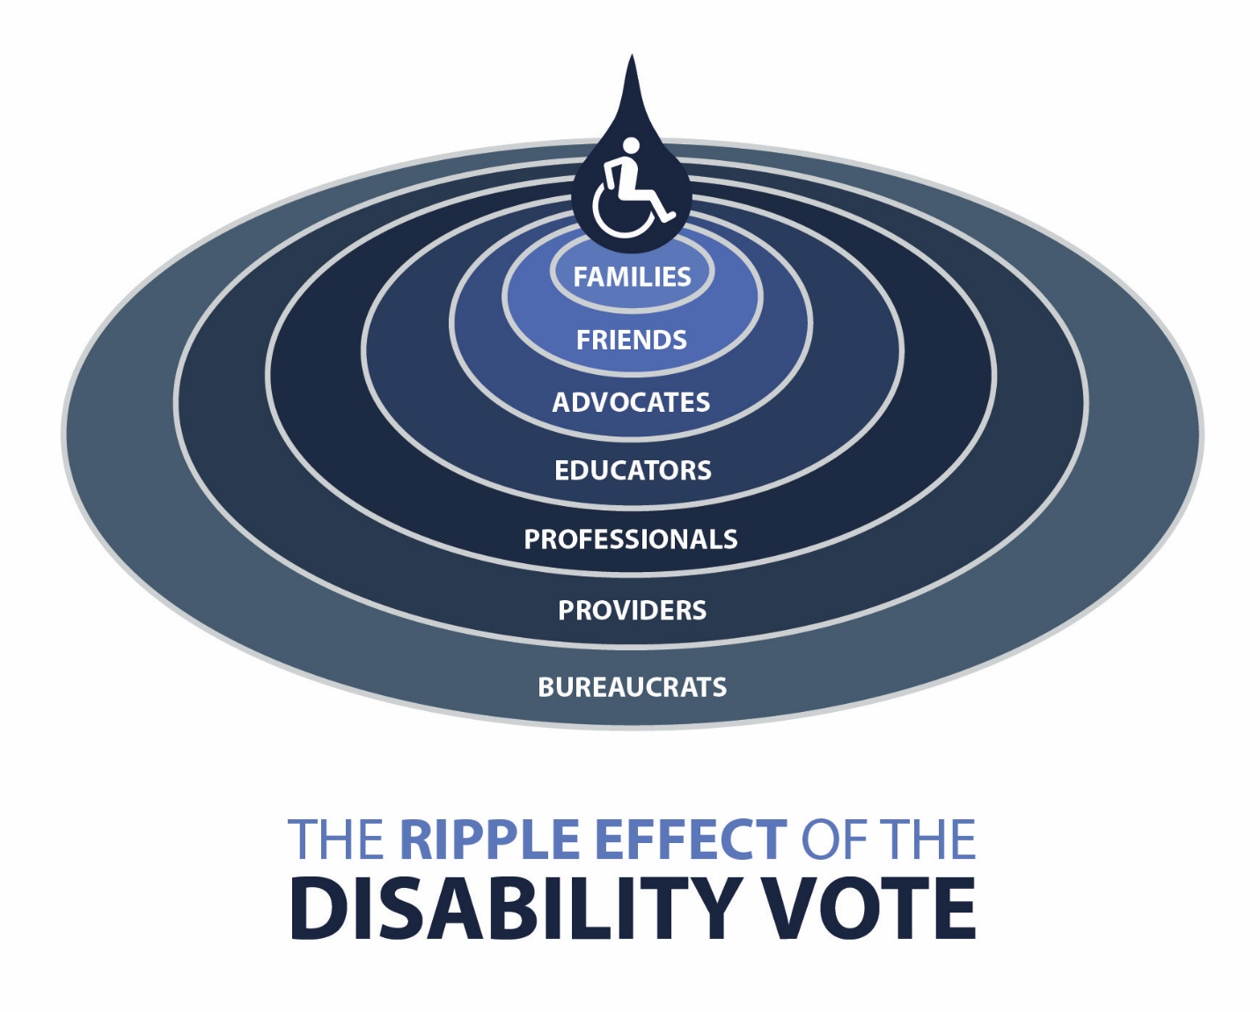

# The Ripple Effect of the Disability Vote

* People with disabilities
* Families
* Friends
* Advocates
* Educators
* Professionals
* Providers
* Bureaucrats

## Important Issues – REV UP Texas

1. Working to educate state policy makers
2. Educating people with disabilities, family members, advocates and the general public on issues effecting people with disabilities
3. Health Care
   1. Access to appropriate medical services in a managed care environment
   2. Physical accessibility to medical services
   3. Access to specialists to meet specific needs of people with disabilities
   4. Addressing discrimination to services because of a preexisting medical condition
   5. Medicaid Expansion
4. Long Term Services and Supports
   1. Getting and keeping folks out of nursing facilities and other institutions
   2. Making managed care work for people with disabilities
   3. Elimination of all waiting lists for people with disabilities and older Texans
   4. Increasing the number of community attendants and to assure they get paid an adequate wage and benefits
5. Rights
   1. Educate people with disabilities of all ages on their rights under disability rights laws like ADA, Fair Housing Act, IDEA and Section 504 of the Rehabilitation Act of 1973
   2. Conduct trainings on strategies to implement disability rights laws
6. Employment
   1. Identify strategies to decrease high unemployment rate of people with disabilities
   2. Educate consumers on Work Incentives/Disincentives
7. Housing – Accessible, Affordable, Integrated
   1. Educate consumers on their rights under housing rights laws
   2. Identify accessible, affordable integrated housing options
   3. Work with Relocation Specialists to identify housing options for people coming out of nursing facilities and other institutions
8. Transportation – Accessible, Integrated
   1. Mainline Ridership Incentives and Training
   2. Paratransit – What Is Its Role?
   3. Accessible Taxicabs
   4. Air Travel
9. Education
   1. Training on IDEA – Implementation/Enforcement
   2. Assure students with disabilities get an adequate Transition Plan before they leave high schools
10. Leadership Development
    1. Training on development of new leaders
    2. Training on use of Social Media
    3. Development of Grassroots Organizations

# How **REVUP MA** Was Organized in Massachusetts

*Written by Christine Griffin & Charlie Carr*

With the uncertain times ahead, now more than ever, we need to continue organizing people with disabilities to register, educate and vote and use your power. Change happens first on the local level; REVUP MA is reaching out to people with disabilities throughout the Commonwealth, getting them to register and vote regardless of party affiliation.

REVUP MA started in the summer of 2015 when the state P&A, the Disability Law Center (DLC) convened a small group of advocates to discuss the formation of a statewide voting task force. This group discussed how to begin work necessary to increase voter registration and to continue the work DLC funded to eliminate barriers to voting that would be anticipated in a presidential election year. As a result of that meeting, DLC began organizing a daylong conference that would bring a statewide group of people with disabilities together to talk about how to organize our communities to work together on voter education, registration and voting.

Prior to that event, DLC’s Executive Director who is also the President of the AAPD Board, worked with the AAPD’s Executive Director and Bob Kafka to discuss what Bob and other advocates were doing in Texas with their REV UP! campaign. We all agreed that this would make a great national campaign that AAPD could lead and that we would attempt to get other states, like Massachusetts, to begin a state REV UP! campaign.

DLC organized and held the first REV UP! MA event in November 2015 to plan for the work necessary to increase registration and voting opportunities for people with disabilities. This event attracted more than 100 people including staff from Independent Living Centers, MA Developmental Disabilities Council, and a wide variety of individuals and organizations working with people with all disabilities. We had several panels, one with Jim Dickson and Michelle Bishop as well as another panel consisting of Bob Kafka, Stephanie Thomas. Jima and Michelle discussed grass roots organizing while Bob and Stephanie talked extensively about REVUP, the Texas-based organization they created that was doing voter registration, education and helping people understand how voting as a bloc can make a measurable difference in the quality of our lives. Bob and Stephanie also discussed ideas about how to engage potential voters with disabilities that were not registered to vote.

The outcome of this meeting became the framework for REVUP MA and we got to work developing a website to use as a marketing and education tool as well as a database to capture contact info from anyone interested in our campaign.

We began seeking opportunities immediately to spread the word about REV UP MA and a smaller group continued to meet and plan. DLC hosted a meeting with the Chairman of the Election Assistance Commission (EAC) in December 2015 which resulted in the EAC deciding to hold a Commission meeting on barriers to voting and access for voters with disabilities in Boston. DLC and the REV UP Team assisted the EAC in finding panelists for the various panels they wanted for their meeting. DLC also organized and planned the second REV UP MA statewide meeting after the Commission meeting to continue our planning activities.

We invited Ted Jackson who gave an excellent presentation on building electoral power and voting accessibility. Attendees were both people and organizations represented at the first meeting and more diverse groups like LGBTQ and youth who also wanted to be heard.

REVUP MA went from conceptual framework to blueprint for implementation after this meeting, creating goals for registrations and committing to attend all the events we could to further educate the community and others about the importance of the disability vote. Over the next 6 months, statewide voter registration drives were held at many local disability organizations, ADA celebrations, and events. DLC hired a young leader in the community to attend as many events as possible to increase voter registration and to obtain signed pledges to vote. During this period over 400 people with disabilities signed pledges to vote.

REVUP MA continued to share important information via the website and two cable TV shows on how to register to vote, as well as information about early registration that was allowed for the first time in Massachusetts during the presidential election. DLC also wrote a proclamation that Governor Baker signed declaring of week of July 11-15, 2016 as Massachusetts Disability Voter Registration Week.

As Election Day approached, the REV UP MA Team also put out positive messages through the website and social media about voter registration and the importance of voting as well as information on who to call if you ran into a barrier on Election Day.

DLC contracted with 8 Independent Living Centers, as they do every Election Day, to conduct barrier surveys at more than a hundred polling places all over the state.

Regardless of who your candidate was, unsubstantiated data suggest that people with disabilities voted in greater number than previous years. If this is true, we can attribute the change to REVUP MA and its grassroots driven focus on improved voter registration and voting outcomes in the disability community.

DLC funded 99% of all REV UP MA activities and marketing tools with PAVA funding and will continue to do so going forward.

## SUMMARY

* Identify Lead Organizations – Call a REV UP Campaign Planning Meeting, the Coalition should be inclusive of all disabilities and identities
* Get your state P&A involved and seek funding for REV UP activities from the P&A’s PAVA funding.
* Decide on a name – REV UP ___________
* Inform your local political parties, the disability community, and the general public about REV UP ____
* Develop your state REV UP Toolkit (a template is available on AAPD’s website) and distribute it widely. Share it with AAPD ([www.aapd.com/REVUP](http://www.aapd.com/REVUP))
* Meet at least every two months; utilize conference calls to keep folks updated
* Identify information about state and local elections (dates, candidates, registration deadlines, ballot initiatives, etc.)